**USER’S MANUAL**

**Inter-Domain Routing Simulator**

**CSC3003S SEPTEMBER 2019**

**1 General Information**

* 1. **System Overview**

The Inter Domain Routing Simulator is an application that simulates a network – showing nodes and the topology of a network and calculating and visualizing the shortest path from one node to another given the number of packets to be transferred.

* 1. **Organization of the Manual**

This manual will have four sections: General Information, System Summary, Getting Started and Using the System.

**2. System Summary**

**2.1 System Configuration**

The Inter-Domain Routing Simulator operates on desktops computers as a desktop application. It is programmed on Python and in order to run it one must have installed the Networkx, Matplotlib and Basemap libraries. If you have these libraries installed you can the easily use the inter domain routing simulator.

**2.2 User Access**

Any individual can use the application you don’t need any registration. You just have to install the necessary libraries

**2.3 Contingencies**

**Data is stored on comma separated valued text files and you need to have enough storage available to store these. If you close the application without saving your work everything will be lost.**

**3.0 Getting Started**

**3.1 Installation**

You need to have python installed on your computer and the libraries mentioned above. Then you just run the application from any python IDE or the command line**.**

**3.2 System Menu**

The interdomain routing simulator has one main User Interface with buttons to do any application function.

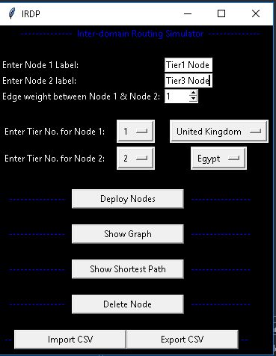

3.2.1 Type of user Input

User Inserts nodes like the way it is displayed below and press deploy nodes to insert the nodes on the graph

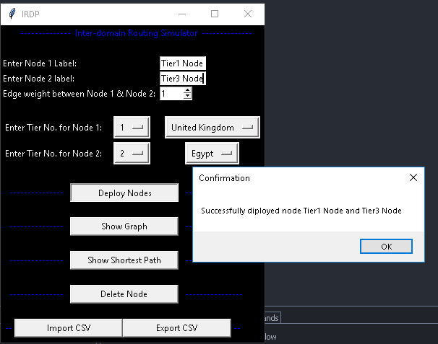

3.2.2 Showing the Graph after inserting nodes

The user should click the show graph button after deploying nodes.

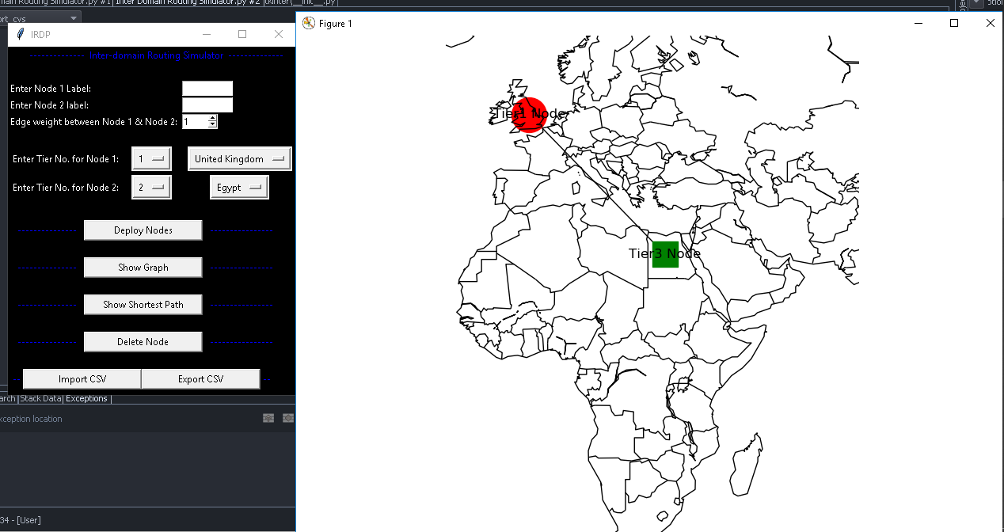

3.2.3 The user can import an existing CSV

They should press the import csv button to do this.

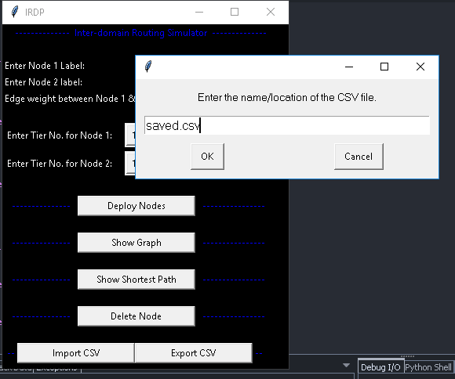

3.2.4 The graph will be displayed as shown below after pressing ok button.

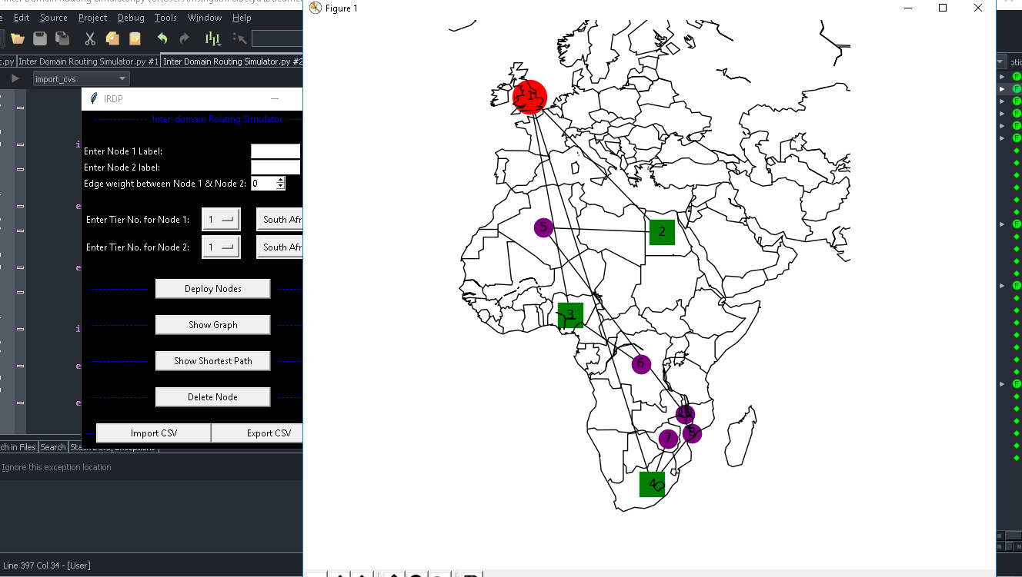

3.3.5 User can press the show shortest path button to display the shortest between 2 nodes. They will also have to choose the algorithm they want to use.

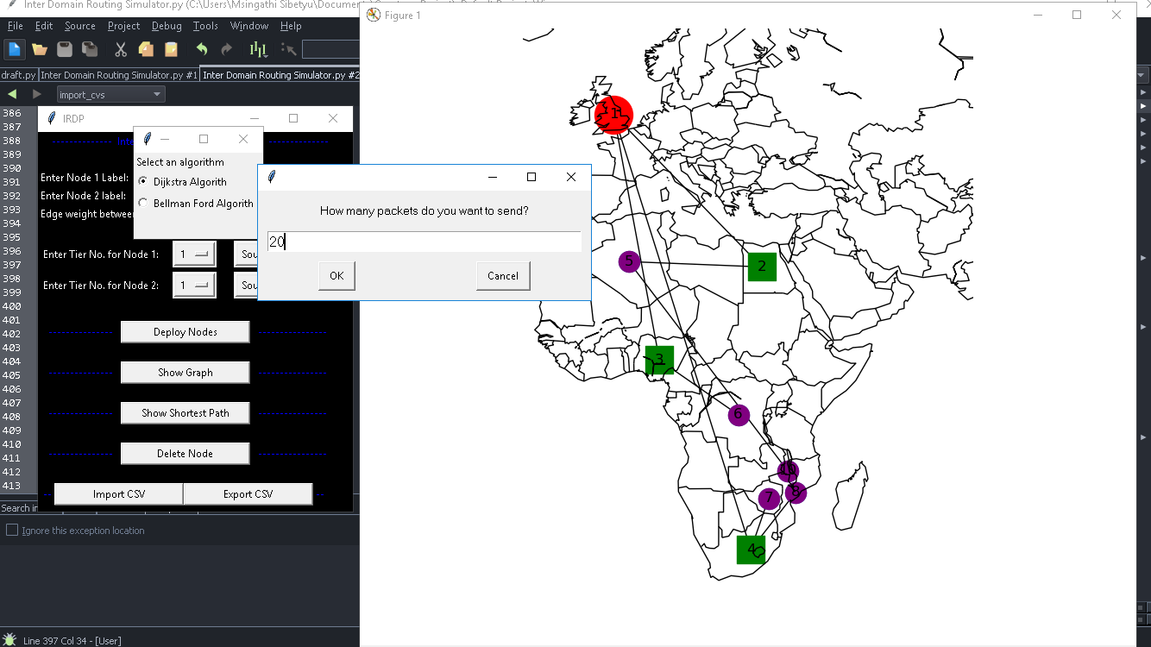

3.3.6 User will enter the nodes they want to calculate the shortest path of as shown below. Two nodes separated by a comma.

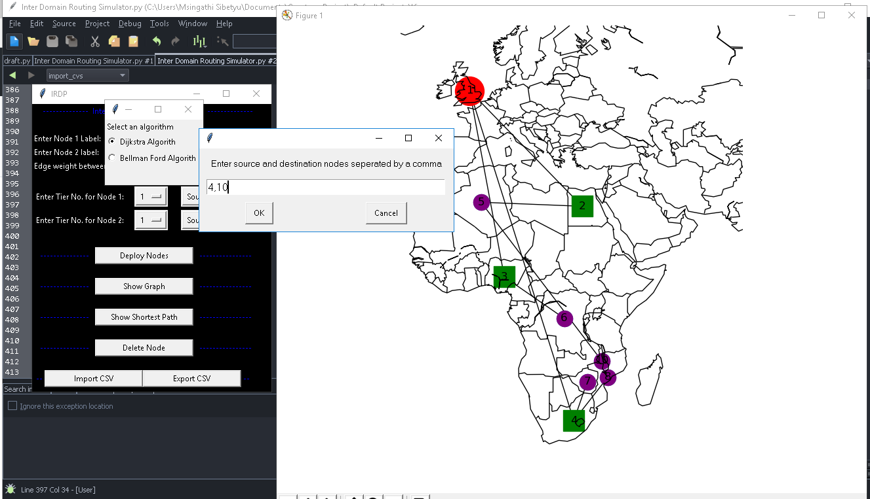

3.4 Exit System

The application has the exit button on the top right corner as any other normal desktop app. User will click that button to close the application.

**4.0 Using the System**

**4.1 User Input**

The application has two text fields that allow the user to enter a set of two nodes. After the user enter the nodes, they will have to use the spin box to indicate the weight of the edge between those two nodes.

The user will then have to use the option menus to select the tiers of the nodes which range from 1 to 3 and they will have to use the other option menus to select the country that each node is in.

**4.2 Buttons**

After User Specifies the node information they will have to deploy the nodes by pressing the “deploy nodes” button. They can deploy as many nodes as they want.

After Deploying nodes, the user can press the “display graph” button to display the graph.

The user can press the “delete node” button to delete any node from the topology.

The user Can press the “show shortest path” button and then choose the algorithm they want to use to show the shortest path. After they will have to enter the number of packets to send and also enter the 2 nodes separated by a comma and press okay. The graph will be shown.

**4.3 Import CSV/Export CSV**

The user can import an existing csv and only show its topology. The user can also configure their own topology and press the export csv button to save their topology.